**Unit 4**

**Ordering Meals**

**Conversation**

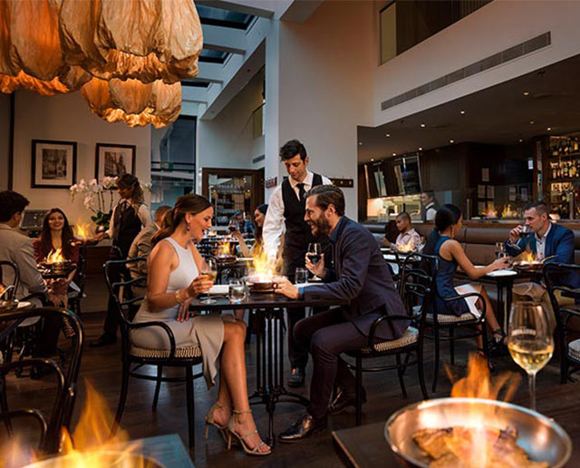

**Breakfast in the hotel**

Waiter : Good morning, sir.

Mr. Steel : Good morning.

Waiter : Would you like to order, sir?

Mr. Steel : Yes, please. I’ll have the continental breakfast.

Waiter : Tea or coffee, sir?

Mr. Steel : Tea, please.

Waiter : And what will you have, madam?

Mr. Steel : I’ll have fruit juice and cereal, an omelette, and toast with marmalade.

Waiter : Would you like tea or coffee, madam?

Mr. Steel : Coffee, please.

**Ordering a meal**

Waiter : May I take your order, please?

Customer: Yes, I’d like a hamburger and a large order of french fries, please?

Waiter : All right. And would you like a salad?

Customer: Yes, I’ll have a small salad.

Waiter : OK. What kind of dressing would you like? We have Thousand Island, Italian, and French.

Customer: Italian.

Waiter : And would you like anything to drink?

Customer: I’d like a large Coke, please.

Waiter : Thank you.

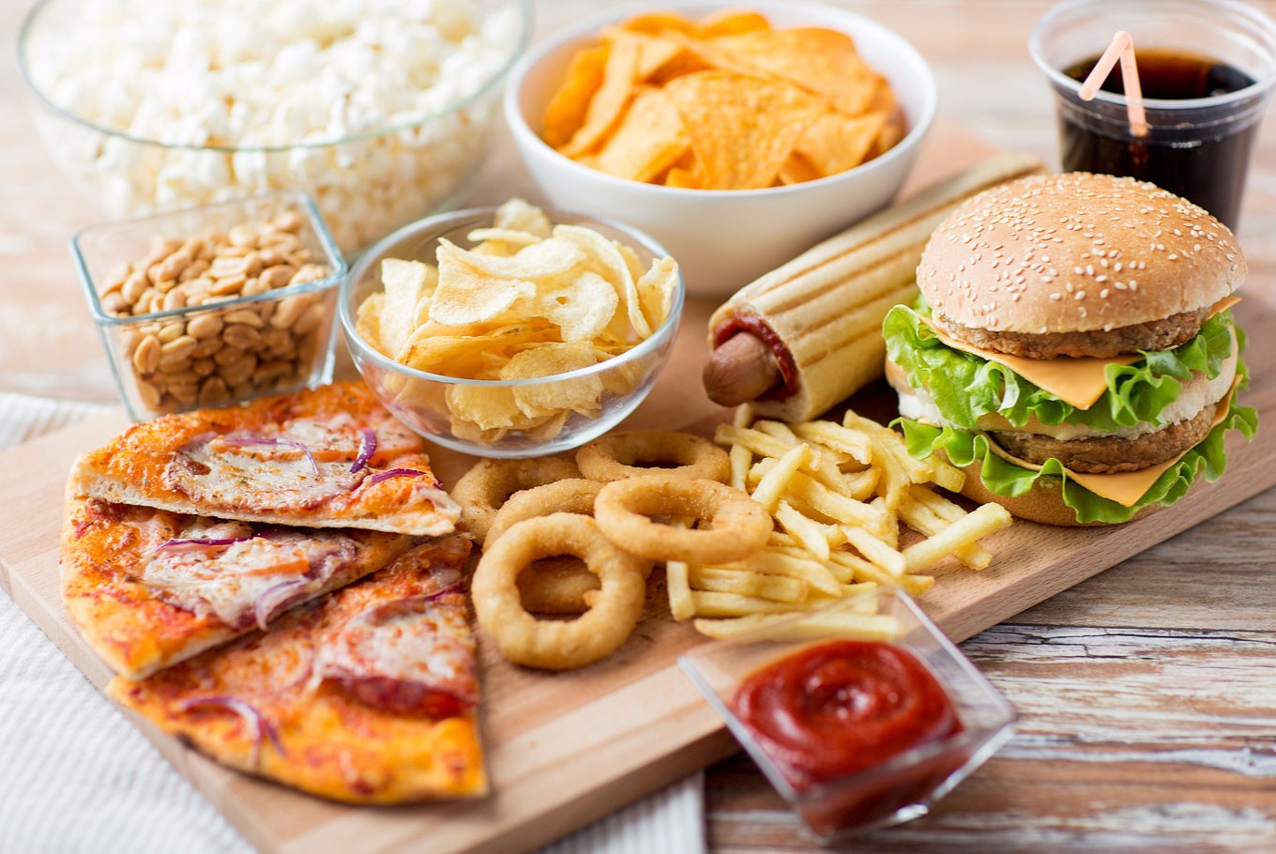

**Ways to say it**

**Taking an order and ordering**

1. A Are you ready to order?

Would you like

What would you like

What will you have?

B Yes, I’d like a steak.

I’ll have fried eggs and sausages, please.

2. A Would you like anything to drink?

something

tea or coffee?

any vegetables?

B Yes, please. I’ll have coffee.

Not yet, thanks.

Yes, I’ll have peas, please.

**COMPLETE THIS DIALOG**

*1. Order what you want for breakfast.*

Waiter: Good morning.

You :………………..

Waiter : Would you like to order breakfast now?

You : Yes, I’ll have ……….

Waiter : Would you like tea or coffee?

You : …………………..

*2. Look at the menu on the next page. Order your lunch. Use these models.*

Waiter : ………………?

You : Yes, I’ll have cream of tomato soup and roast chicken.

Waiter : ……………?

You : I’d like French fried potatoes, carrots and peas.

Waiter : …………?

You : Yes, I’ll have orange juice, please?

**Discussing a dish**

Simon : What do you call this? It’s very nice.

Mrs. Soemardi: That’s called *gado-gado.* It’s a kind of salad.

Simon : It’s very nice. What’s it got in it?

Mrs. Soemardi : Vegetables, potato and a peanut sauce.

**Exercise**

1. *Look at this table and the dialogue below.*

**Name of dish Type Contents**

Pumpkin pie a dessert pumpkin and egg

Casserole a meat dish beef

Fish balls a fish dish fish and potato

Spaghetti a pasta noodles and sauce

Baked tomatoes a vegetable dish tomatoes

*Soto* a soup vegetables and chicken

A: What’s that?

B: It’s pumpkin pie. It’s a dessert.

A: What’s it got in it?

B: Pumpkin and egg. Like to try some?

A: Yes, please.

*Practice dialogues like this about the other dishes above.*

**B. Vocabulary Focus: Countable and Uncountable Nouns**

1. *Countable nouns have a singular and plural form (e.g. an apple, apples). Arrange these nouns into the lists below. Then add two more countable nouns to each list.*

An apple beans carrots oranges potatoes

Bananas bowls a knife plates

*Fruit vegetables tableware*

……… …………. …………

……… …………. ………….

……… …………. ………….

1. *Uncountable nouns do not have a plural form (e.g. beef). Arrange these nouns to each list.*

Beef yogurt cream orange juice

Rice pork flour water

*Drinks Meat Grain and grain products Milk products*

……… ……… ………………………… …………….

…………. ……….. ………………………. ………………

………… ……….. ………………………. ………………

………….. ……….. ………………………. ………………

**C. Grammar Practice: Modal Verbs would and will**

*a) We use will (‘ll) when we decide to do something at the time of speaking:*

- Oh, I’ve left the door open. **I’ll go** and shut it.

- ‘What would you like to drink?’ ‘**I’ll have** lemonade, please.’

- ‘Did you phone Ann?’ ‘Oh, no, I forgot. **I’ll do** it now.’

- I’m too tired to walk home. I think **I’ll get** a taxi.

You cannot use the present simple (I do) in these sentences

* **I’ll go** and shut it. (not ‘I go and shut it’)

*Do not use* ***will*** *to say what someone already decided to do or arranged to do:*

* I can’t meet you tomorrow because my parents are coming to see me. (*not* ‘my parents will come’)

*The negative of* ***will*** *is* ***won’t*** *(or* ***will not****):*

- Receptionist : I’m afraid Mr. Wood can’t see you until 4 o’clock

You : Oh, in that case I won’t wait

*We often use* ***I think I’ll……*** *Or* ***I don’t think I’ll…..*** *when we decide to do something:*

* I think I’ll stay at home this evening
* I don’t think I’ll go out tonight. I’m too tired

*b) We often use* ***will*** *in these situations:*

*Offering* to do something*:*

* That bag looks heavy. I’ll help you with it.
* ‘I need some money.’ ‘Don’t worry. I’ll lend you some.’

*Agreeing* or *refusing* to do something

* A: You know that book I lent you? Can I have it back?

B: Of course. **I’ll bring** it back this afternoon.

* I’ve asked John to help me but he **won’t.**
* The car **won’t** start. (=the car ‘refuses’ to start)

*Promising* to do something:

* Thank you for lending me money. **I’ll pay** you back on Friday.
* I **won’t** **tell** Tom what you said, I promise.
* I promise **I’ll** **phone** you as soon as I arrive.

*Asking* someone to do something (**will you….?):**

* **Will you shut** the door, please?
* **Will you** please be quite? I’m trying to concentrate.

**Exercises**

*1. In this exercise you have you have to complete sentences with I’ll + a suitable verb.*

*Example*: I’m too tired to walk home. I think I’ll get a taxi.

1. I feel a bit hungry. I think ……………… something to eat.
2. it’s too late to telephone Tom now. ………………him in the morning.
3. ‘It’s a bit cold in this room.’ ‘Is it?...................on the heating then.’
4. ‘We haven’t got any cigarettes.’ ‘Oh, haven’t we? …………..and get some.’
5. ‘Did you write that letter to Jack?’ ‘Oh, I forgot. Thanks for reminding me. ……….it this evening.’
6. ‘Would you like tea or coffee?’ ‘………..coffee, please.

*2. Now you have to use* ***I think I’ll……..*** *or* ***I don’t think I’ll…..*** *Read the situation and then write your sentence.*

*Example:*

It’s cold. You decide to close the window. I think I’ll close the window.

It’s raining. You decide not to go out. I don’t think I’ll go out.

1. You feel tired. You decide to go to bed. I ……………….
2. A friend of yours offers you a lift in his car but you decide to walk. Thank you but………….
3. You arranged to play tennis. Now you decide that you don’t want to play. ………………….
4. You were going to go swimming. Now you decide that you don’t want to go. …………………

*3. Now you have to offer to do things. Tom has a lot of things to do and in each case you offer to do them for him.*

*Example:*

Tom : Oh, I must do the washing-up.

You : No, it’s all right. I’ll do the washing-up.

1. Tom : Oh, I must get dinner ready. You: No, it’s all right. I ………….

2. Tom: Oh, I must do the shopping. You: No, ………………………….

3. Tom: Oh, I must water the plants. You: ………………………………

4. This time you have to agree and promise to do things

Example:

A: Can you clean the windows? B: Sure, I’ll clean them this afternoon.

A: Do you promise? B: Yes, I promise I’ll clean them this afternoon.

1. A: Can you phone me later? B: Sure, ……………………….tonight.

A: Do you promise? B: Yes, ……………………………………..

2. A: Can you repair the clock? B: Okay, ……………………tomorrow.

A: Do …………………….? B: …………………………………….

3. A: Please don’t tell anyone. B: All right, I won’t tell anyone.

A: ………………………..? B: …………………………………….

4. A: Please don’t hurt me. B: Don’t worry, …………………….

A: …………………………? B: …………………………………….

**Reading**

**Fast Food**

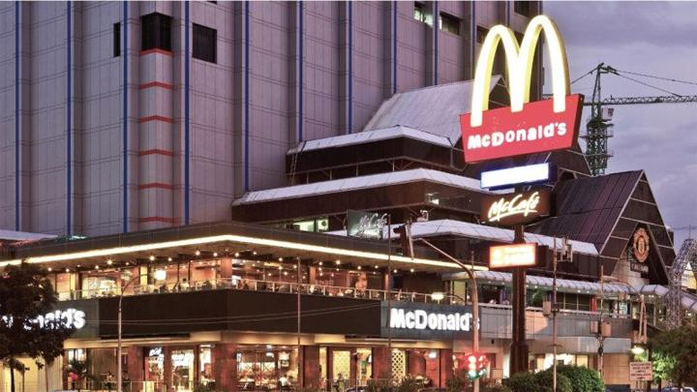

Today you can find some food restaurants in almost every big city. In some places, you stand in a line and get a hamburger or hot dog in paper bag; in other you can pick up a tray of fish, chicken, pizza or even Mexican and Chinese food; and in some fast food places you can even drive your car up to a window and place your order. A few minutes later worker passes you your food through the window and you can drive away and eat it in your car.

In New York, Paris, Tokyo, Singapore and thousands of other cities around the world, new fast food restaurants open every day. But why do people prefer fast food restaurants to more comfortable restaurants where they can sit quietly at a table and watch the world go by?

Two things make fast food restaurants popular. Speed and price. People’s time is valuable. They may have only thirty minutes for lunch. They don’t want to waste a lot of time eating or preparing food. The service is fast, so they can order what they want, eat it, and be finished in less than fifteen minutes. And prices are inexpensive. Because of large number of meals sold every day in fast food restaurants, cost are kept low. There are over 35 billion (35,000,000,000) hamburgers sold every year in the United States alone! Another thing people like is that they can be sure what the food will taste like in a fast food restaurant. The major international fast food companies like Mc Donald’s and A&W make sure that a hamburger sold at the store in Boston will taste exactly the same as one sold in New York and not very different from one bought in Bangkok or Jakarta.

Critics of fast foods say that they are ‘junk foods’ – food which has no nutritional value. They say fast food, such as hamburgers, contain too much salt, carbohydrate, and fat. But one thing is sure: people everywhere like fast foods and they find it a convenient and economical way to eat.

*1. Choose in the best answer.*

1. In fast food restaurants you can buy (a) only hamburgers, (b) pizza, (c) many different kinds of food.

2. In fast food restaurants people usually eat in about (a) five minutes, (b) fifteen minutes, (c) thirty minutes.

3. The main reason fast food restaurants are popular is because of their (a) tasty and delicious meals, (b) location, (c) price and convenience.

4. A hamburger sold at McDonald’s in San Francisco and one bought at McDonald’s in Washington, should taste (a) quite different, (b) nearly the same, (c) the same.

5. The food sold at fast food restaurants (a) is very nutritious, (b) is good for you (c) contains some things which may not be good for health.

*II. Match the words which are opposites.*

1. expensive a. slow

2. worthless b. noisy

3. popular c. valuable

4. fast d. economical

5. sure e. unpopular

6. quiet f. uncertain

*III. Use these words from the passage to complete the sentences.*

Find, stand, place, prefer, waste, order, taste, contain.

1. Vegetables do not ………. fat
2. Meat loses its …………. if it is cooked for too long.
3. Dogs ………to eat uncooked meat to cooked meat.
4. In a restaurant you usually give your ………..to the writer or waitress.
5. People often ……….food by cooking more than they can eat.
6. Most people ………….that Indian food is very hot.
7. You often have to……….in a line and collect your own food in a canteen or cafetaria.
8. The Japanese always …………….food on a dish so that it looks atractive.

**Writing**

*Read this description*

Breakfast is usually quite a small meal for me. I usually have just a slice of toast and coffee. I have breakfast at around 7 o’clock and then I leave for the office. Lunch is not a very big meal for me. I usually have lunch in the office canteen at about 12.30. Sometimes I bring sandwiches from home and just buy a drink. At other times I buy something from the canteen, such as spaghetti or a hamburger, with something to drink. The evening meal is the biggest meal. I usually have dinner with my family at around 7 o’clock. We always have a meat or a fish dish, and several vegetable dishes served with rice or potatoes. Sometimes we have a dessert as well, such as fresh fruit, ice cream or cake. After dinner I like to drink a cup of strong black coffee.

*Write a description like the above of what you usually have for breakfast, lunch and dinner.*

* Mention the size of the meal (big, quite, quite small)
* Which is the biggest meal of the day?
* What do you drink with each meal?
* What time do you have each meal?